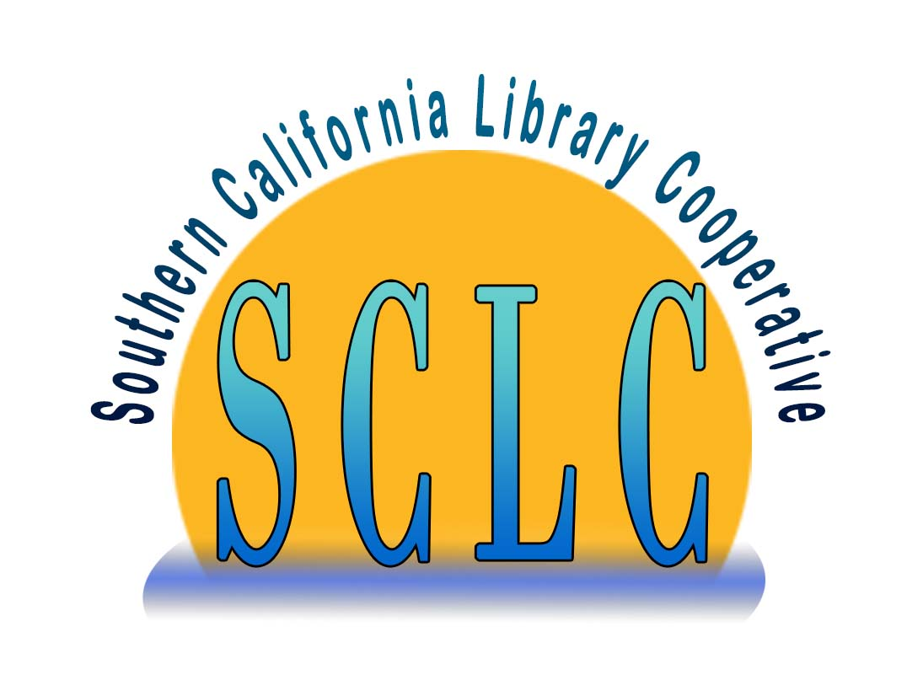
Southern California Library Cooperative
Executive Committee Meeting
October 22, 2020
9:00 – 10:00am

Minutes
Approved November 11, 2020

Attendance
Conwell, Christine – Moorpark
Cosby, Patricia – Camarillo
Cousin, Heather – Thousand Oaks
Perera, Michelle – Pasadena
Shupe, Robert – Palmdale
Stone, Janet – Glendora
Walker-Lanz, Jesse – LA County

Other
Bednarski, Diane – SCLC
Graver, Lori - SCLC

Absent
Hughes, Charles – Signal Hill

- Call to Order and Roll Call Robert Shupe
Meeting called to order at 9:03am.

- Public Forum Robert Shupe
Opportunity for any guest or member of the public to address the committee on any item of Executive Committee business.
None.

- Consent Calendar Robert Shupe
  - Minutes from June 30, 2020
  - Minutes from August 27, 2020
MSP (Stone/Conwell) to approve minutes and pass Consent Calendar.

- Adoption of Agenda Robert Shupe
MSP (Cousin/Perera) to adopt agenda as presented, without change.

- Closed Session Diane Bednarski
Potential litigation concerning contractor compensation.

- Reconvene to Open Session Robert Shupe
Meeting reconvened to Open Session at 9:51am and a summary of non-confidential matters discussed during the closed session was provided. The Executive Committee and SCLC Executive Director discussed the matter of wage claims filed by Mr. Sergei Kagno with the California Labor Commissioner’s Office and advice provided by SCLC’s legal counsel regarding potential financial exposure and next steps. Per the Labor Commissioner’s Office, maximum amount that can be pursued by the claimant is $661.88 representing mileage, wages and liquidated damages, if determined that claimant performed work as an employee rather than as a contractor. A hearing will be scheduled in 6 – 18 months, where Executive Director Diane Bednarski will represent SCLC.

- Updates to SCLC Bylaws and Standing Rules Diane Bednarski
MSP (Stone/Perera) to copy Bylaws Article VI, Section 4, into Article VII to make it clear that Brown Act rules apply to all committees, and to authorize SCLC to distribute the draft amended bylaws to the SCLC Administrative Council two weeks prior to the next SCLC Administrative Council meeting on November 19, 2020 to be considered for adoption.

- Adjournment
Meeting adjourned at 10:26am.

Respectfully submitted by Lori Graver on November 19, 2020

