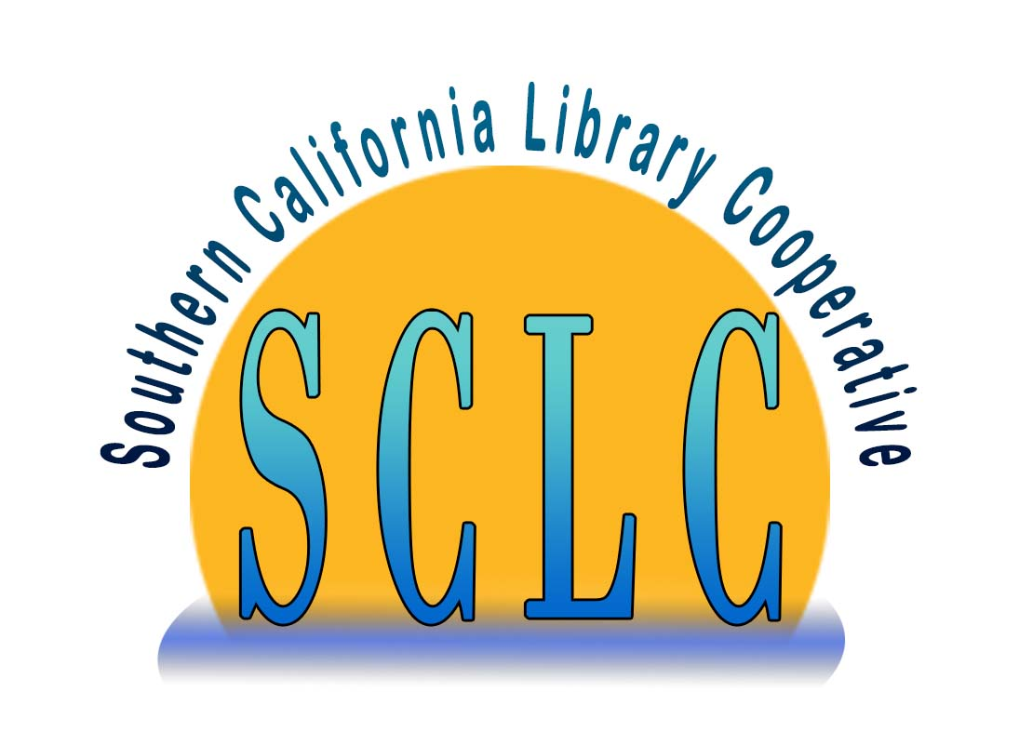

**Southern California Library Cooperative**

**THE REGULARLY SCHEDULED**

**AUDIT & FINANCE COMMITTEE**

**MEETING FOR**

**NOVEMBER 6, 2024**

**HAS BEEN CANCELED**

Southern California Library Cooperative

222 E. Harvard St. • Glendale, California 91205

(626) 283-5949 • Fax (626) 283-5949

Website : http://www.socallibraries.org • E-mail : sclcadmin@socallibraries.org